Report No. 11492

A350-1000F MDCLS Cargo Display Panel (CDP) Platform Software Requirement Specification

Module: | CDP Plat SW SRS Module
Configuration Type:
Configuration: | Stream

ANCRA INTERNATIONAL, LLC
601 South Vincent Avenue
AZUSA, CA 91702

Ancra International LLC proprietary rights are included in the information disclosed herein. Recipient, by accepting this document, agrees that neither this document nor the information disclosed herein, nor any part thereof shall be reproduced or transferred to other documents or used or disclosed to others except as specifically authorized in writing by Ancra International LLC. Unpublished – all rights reserved under copyright laws.
© 2023 Ancra International LLC

Signature Page
Ancra Signatures
Prepared By: |  |  | 01/01/2023
 | Name here |  | Date
Checked By: |  |  | 01/01/2023
 | Name here |  | Date
Approved By: |  |  | 01/01/2023
 | Name here |  | Date

Customer Signature
Approved By: |  |  | 01/01/2023
 | Name here |  | Date
Approved By: |  |  | 01/01/2023
 | Name here |  | Date
Approved By: |  |  | 01/01/2023
 | Name here |  | Date

Revision Record
Rev.  Level | Rev.  Date | Prep.  By | Check.  By | Effected  Pages | Change  Description

Table of Contents
1 Scope 8
2 Reference Document 9
3 Acronyms & Initialism 11
4 Software Architecture 15
5 Software Overview 16
5.1 Software Description 18
6 Partitioning 19
7 Memory Constraints 21
8 High Level Requirements 21
8.1 Platform Software High-Level Requirements 22
8.1.1 CDP Power On Self- Test (POST) 22
8.1.2 CDP Driver Requirements 32
9 Requirements Traceability Matrix 36
10 10 39

List of Figures
Figure 1 - CDP CIRD in Requirement Hierarchy 9
Figure 2 - CDP SW Architecture 16
Figure 3 - CDP Software overview 17
Figure 4 - Layered view of CDP Platform 19
Figure 5 - CDP Modes 19
Figure 6 - Memory Partition 20

List of Tables
Table 1 - Project Documents 10
Table 2 - Industry Standards 10
Table 3 - Customer Documents 11
Table 4 - Acronyms 15
Table 5 - Memory Size 20
Table 6 - SMARC module GPIO configuration 25
Table 7 - CDP HARDWARE PIN PROGRAMMING DISCRETES ASSIGNMENT 26
Table 8 - UART Configuration 34
Table 9 - I2C Devices and their corresponding Addresses 35
Table 10 - Forward Requirement Traceability Matrix 37
Table 11 - Backward Requirement Traceability Matrix 39
Table 12 - DO-178C Cross Reference Matrix 40

Scope
This Software Requirements Specification (SRS) defines the High-Level Requirement (HLR) required for certification of the Cargo Display Panel Platform Software Computer Software Configuration Item (CSCI) of Main Deck Cargo Loading System (MDCLS). Each HLR is tagged with a unique trace tag and bidirectional trace is provided between the HLR and the parent system level requirement that it was decomposed from. This SRS also identifies derived requirements that do not directly trace to system requirement, but which are necessary to provide a complete description of all functions the software must provide. These derived requirements will be provided with justification for their existence in the SRS.
This document falls at Tier 3 of the requirement hierarchy,
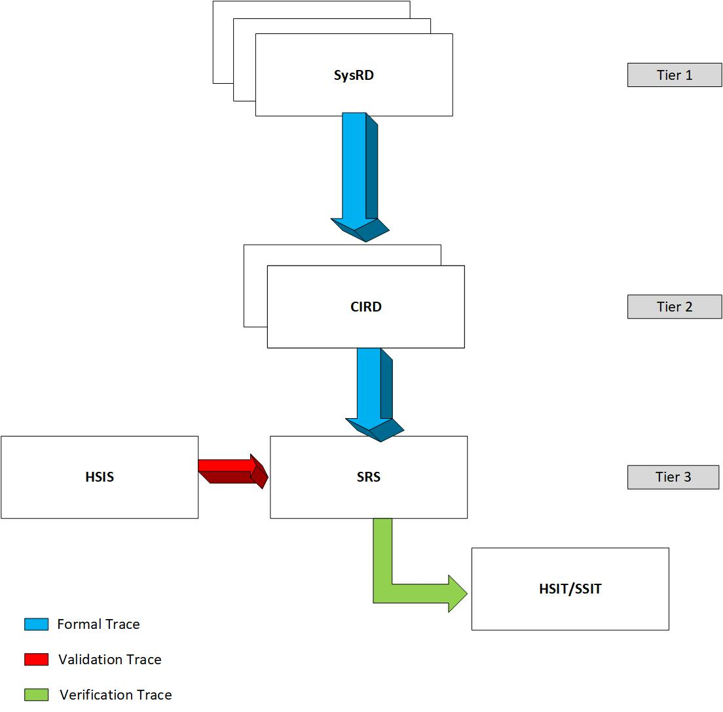
Figure 1 - CDP CIRD in Requirement Hierarchy

Reference Document
This section lists the project documents, customer documents, standards, procedures, government, and industry documents that are applicable to this document.
Document | Revision / Issue No | Title
11504 | B | Software Development Plan
11505 | C | Software Verification Plan
11506 | B | Software and AEH Quality Assurance Plan
11507 | C | Software and AEH Configuration Management Plan
11508 | C | Software Requirements Standards
11509 | C | Software Design Standards
11510 | C | Software Code standards
11646 | B | Software COTS Management Plan
11644 | D | Plan for Software Aspects of Certification for CDP
11636 | B | CDP Configuration Item Requirements Document
11671 | B | Cargo display panel AEH Requirement Document
11672 | B | Cargo display panel AEH Software Interface Specification
11594 | D | CAN Interface control document
11632 | C | System Requirement Document (SysRD)
11555 | D | System Configuration Index (SysCI)
11595 | B | Interface Control Document for A350 Main Deck Cargo Loading System Electrical
Table 1 - Project Documents
Document | Description
ED-12C/DO-178C | Software Considerations in Airborne Systems and Equipment Certification
ISO 11898-1 | International Organization of Standardization 11898-1

Table 2 - Industry Standards
Document | Description
V5024PTSS21002 - PTS Main Deck Cargo Loading system - Issue: 2.0 | Functional Requirement for the MDCLS

Table 3 - Customer Documents

Acronyms & Initialism
Acronym | Description
ABD | Airbus Directive
AC | Alternating Current
AEH | Airborne Electronic Hardware
AFDX | Avionics Full Duplex Switched Ethernet
AFT | Afterward
AMC | Acceptable Means of Compliance
API | Application Programming Interface
ARINC | Aeronautical Radio Incorporated
ARP | Aerospace Recommended Practice
ATA | Air Transport Association
ATRU | Auto Transformer Rectifier Unit
BIOS | Basic Input/Output System
BIT | Built-in Test
BITE | Built-in-test-equipment.
BKLT | Booklet
BLDC | Brush Less Direct Current
BSP | Board Support Package
CAN | Controller Area Network
CBIT | Continuous Built-in test
CCB | Change Control Board
CDP | Cargo Display Panel
CIRD | Configuration Item Requirement Document
CMS | Central Maintenance System
COTS | Commercial-Off-The-Shelf
CP | Control Panel
CPIOM | Core Processing and Input / Output Module
CPLD | Complex Programmable Logic Device
CPU | Core Processing Unit
CRC | Cyclic Redundancy Check
CRDC | Common Remote Data Concentrator
CSCI | Computer Software Configuration Item
CTS | Clear to Send Signal
DAL | Design Assurance Level
DC | Direct Current
DDR | Double Data Rate
DFS | Detailed Functional Specification
DLA | Data Loader Application
DLS | Data Loading System
ECU | Electronic Control Units
ED | EUROCAE Documents
EEPROM | Electrically Erasable Programmable Read-Only Memory
eMMC | Embedded multimedia card
ESPI | Enhanced Serial Peripheral Interface Bus
EUROCAE | European Organization for Civil Aviation Equipment
FD | Flexible Data Rate
FDAL | Function Development Assurance Level
FIN | Functional Item Number
FWD | Forward
GB | Giga byte
GND | Ground
GPIO | General Purpose Input/Output
HA | Hosted Application
HD | High Definition
HLR | High Level Requirement
HSIT | Hardware Software Integration Testing
HW | Hardware
HZ | Hertz
I2C | Inter-Integrated Circuit
ICD | Interface Control Document
ICP | Inside Control Panel
ID | Identification
IMA | Integrated Modular Avionics
IO | Input Output
ISO | International Organization for Standardization
LCD | Liquid Crystal Display
LCP | Local Control Panel
LH | Left Hand
LRU | Line Replaceable Unit
LVDS | Low Voltage Differential Signal for LCD displays
MB | Mega byte
MCP | Master Control Panel
MDCLS | Main Deck Cargo Loading System
MS | Milli Second
NVM | Non-volatile Memory
OCP | Outside Control Panel
OPR | Open Problems reports
OPS | Operational
OPSW | Operational Software
OS | Operating System
PAR | Pre-Assembled Rack
PDU | Power Drive Unit
PGOOD | Power GOOD
PID | Proportional-Integral-Derivate
PIN | Personal Identification Number
POST | Power On Self Test
PTS | Purchaser Technical Specification
PWM | Pulse Width Modulation
RAM | Random Access Memory
RFS | Root File System
RH | Right Hand
ROM | Read Only Memory
RTCA | Radio Technical Commission of Aeronautics
RTS | Request to Send Signal
RX | Reception
SAE | Society of Automotive Engineers
SBIT | Start up Bit
SDD | Software Design Document
SDP | Software Development Plan
SMARC | Smart Mobility Architecture
SPDB | Secondary Power Distribution Boxes
SPI | Serial Peripheral Interface Bus
SRS | Software Requirement Specification
SSIT | Software-Software Integration Test
SVCP | Software Verification Cases and Procedures
SVP | Software Verification Plan
SW | Software
TBD | To Be Discuss
TX | Transmit
UART | Universal asynchronous receiver/transmitter
UI | User Interface
ULD | Unit Load Device
USB | Universal Serial Bus
VDC | Volts Direct Current
WDG | Watchdog
WDI | Watchdog Input
WDT | Watchdog Timer
Table 4 - Acronyms

Software Architecture
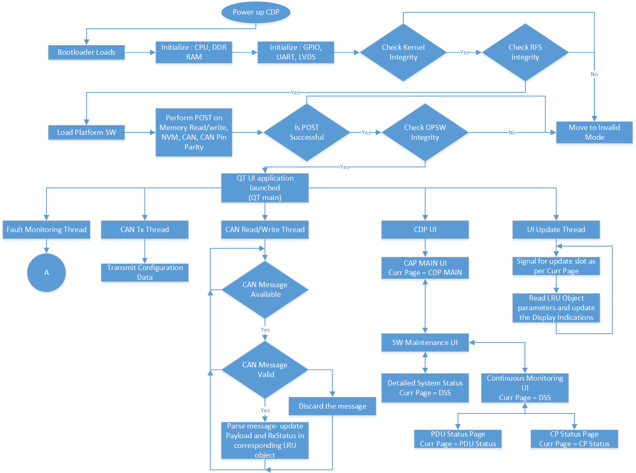
Figure 2 - CDP SW Architecture

Software Overview
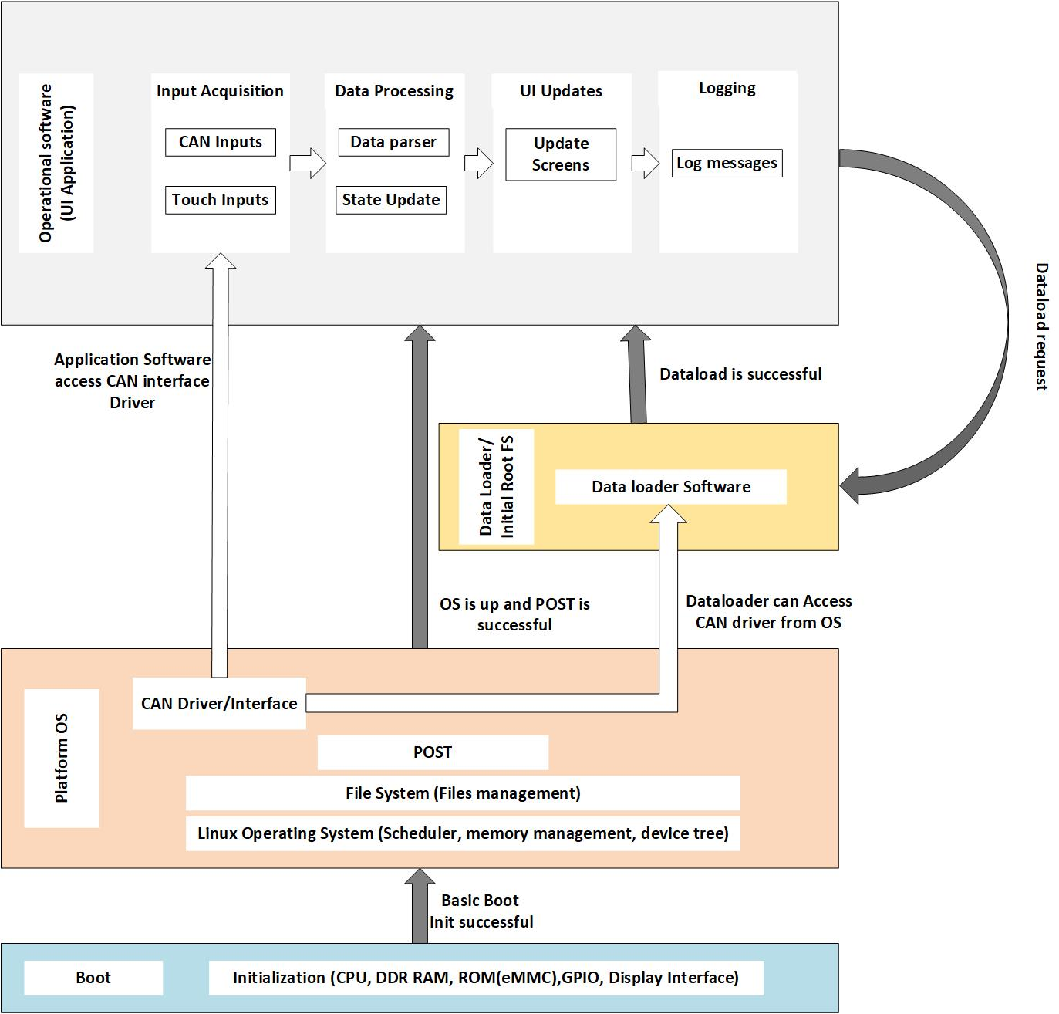
Figure 3 - CDP Software overview
CDP uses a Linux OS as Platform software. The Platform software is required for Memory management, Resource management, host File Systems, Scheduling and provide the board support package for all the interfaces/peripherals.
CDP transitions from Bootloader to Platform Software after successful basic boot initialization. Platform software performs complete hardware initialization and transition to other CSCIs when valid conditions are met. SBIT runs from the Platform Software and checks for any Faults, if there are any faults it will log them. After SBIT is successful, CDP runs the Operational Software. On reception of a Dataload request, the Operational Software runs the Dataloader. Dataloader, after a successful load operation starts the updated Operational Software. In case of failure in any of the CSCIs, CDP logs fault in the NVM and goes into Invalid mode. CDP Dataloader software and Operational software receives CAN messages from cRDC and transmits only status.

Software Description
The Cargo Display Panel of MDCLS an Intel Atom processor-based Touch Screen panel for status reporting and maintenance. An application with multiple screens to display status and maintenance information and take touch inputs from user are hosted on Linux OS.
The Linux OS provides
- Linux Kernel – All generic OS capabilities like scheduler, memory management, resource management modules and filesystem support and Board Support Package – to initialize all the interfaces and hardware blocks on the SoC. BSP is board specific and is customized according to the CDP hardware. BSP will handle CPU, Primary memory, pinmux for all peripherals/interfaces.
- Root Filesystem – Contains all packages, libraries required to run applications.
The below Figure- 3 provides Layered structure of CDP CSCI's and description of the Software(s) under scope.
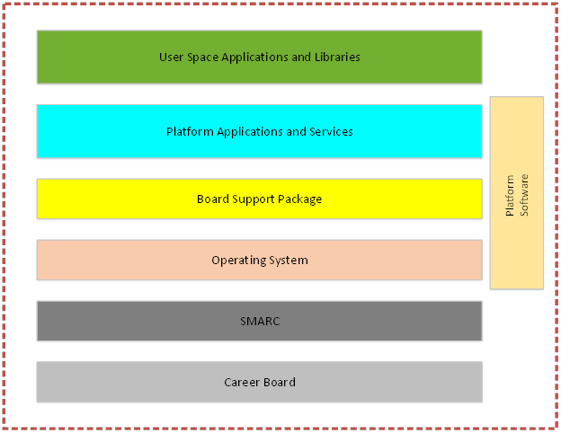
Figure 4 - Layered view of CDP Platform
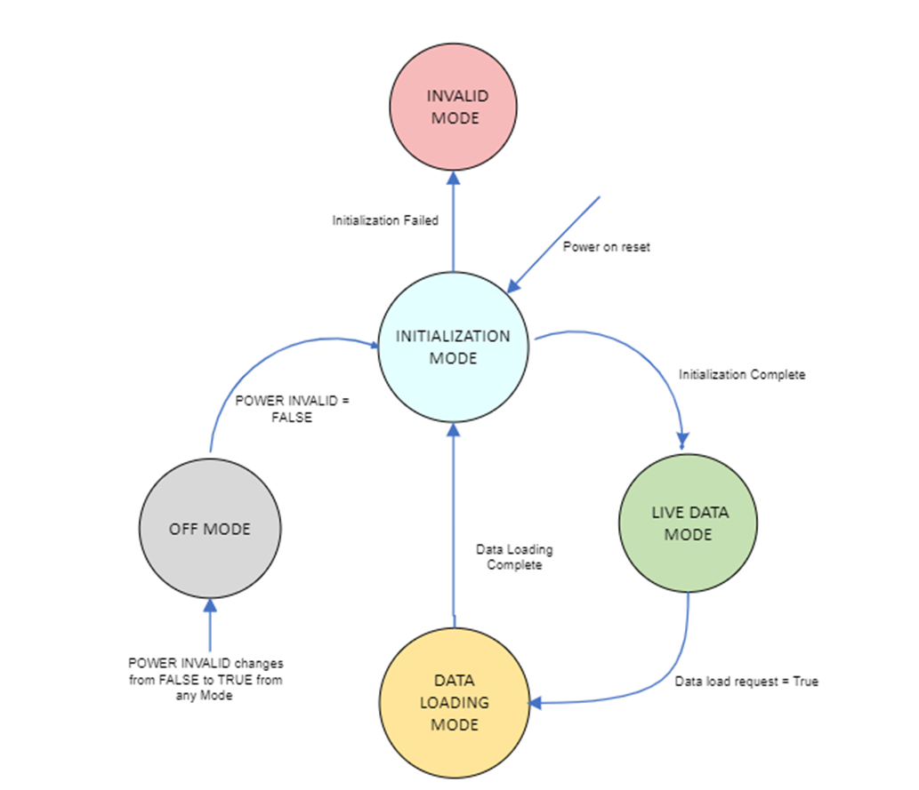
Figure 5 - CDP Modes

Partitioning
The CDP Bootloader software, CDP Platform software, CDP Dataloader and CDP Operational software have a partitioning that isolates them temporally and spatially, which prevents inadvertent execution of the Bootloader and Data Loader software.
The CDP will power up into the Bootloader software. The Bootloader software loads the Platform software and Initial Root File System. The initial Root File System determines if the control needs to be transferred to Dataloader software or to Operational Software. Any failure will result in the CDP staying in the Bootloader software.
As the CDP Software does not have direct access to physical addresses of the storage, partitioning will be taken care by memory management unit. The details of partitioning will be captured as part of Software Product Specification (Report No: 11751).
The CDP Storage will be partitioned as shown in the Figure 5 below and will have size and access permissions has mentioned in Table -5.
Note: The storage partitioning is not handled by the Platform SW.
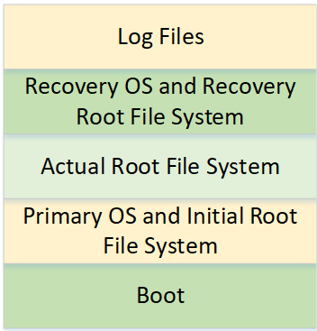
Figure 6 - Memory Partition

Partition Number | Partition Description | Size in MB | Access Permission
1 | Boot | 32 | Not Accessible
2 | Primary OS and Initial Root File System | 512 | R/W
3 | Actual File System | 1024 | R/W
4 | Recovery OS and Recovery File System | 512 | R/W
5 | Log Files | 128 | R/W
Table 5 - Memory Size
The Linux memory partition layout with initial RFS and recovery OS is as follows:
- Initial Root filesystem
  - This is a small, read-only filesystem that is loaded into memory when the system boots. It contains the essential drivers that are needed to boot the system.
- Root filesystem
  - This is the main filesystem of the system. It contains the operating system, applications, user data, and other files.
- Recovery OS and Recovery File System
  - This is a small, bootable operating system that can be used to recover the system if it becomes corrupted. It contains a limited set of tools that can be used to repair the system or restore it from a backup and it contains a read-only filesystem that is loaded into memory when the system boots. It contains the kernel and essential drivers that are needed to boot the system.
The Linux memory partition layout is designed to be as efficient as possible. The initial RFS is loaded into memory first, so that the kernel can start loading the rest of the system. The recovery OS is stored in a separate partition, so that it can be used to recover the system even if the root filesystem is corrupted.
The RFS is the first partition that is loaded into memory when the system boots. If the RFS is small, then the boot process will be faster. There are a few reasons why using a smaller RFS can improve boot time. First, the kernel will need to load fewer files into memory. This can save time because the kernel does not have to wait for all the files to be loaded before it can start executing. Second, the kernel will not have to scan as many files for changes. This can also save time because the kernel does not have to wait for all the files to be scanned before it can start executing.

Memory Constraints
CDP is equipped with 8GB of DDR4 RAM. Complete Platform Software and Operational Software together will require about 2GB of RAM. CDP does not have any constraints with respect to memory utilization.

High Level Requirements
This section captures the high-level requirements and derived high-level requirements that are developed based on system requirements as per the Software Requirements Standards defined as part of the Planning Process. Refer the operating guidance for software requirement process for the detailed guideline on the HLR development
ID:CDP-PLAT-SW-SRS-91260
The CDP Platform Software shall use the Linux Kernel (Version 5.4.12) in its OS as a COTS components.
Applicability: SW
Object Type: Derived
Rational for Derived Req:The Linux Kernel is the main component of Platform Software that provides all OS services along with the Root file system.
Verification Method: Analysis
Safety Tag: true
Safety Impact: false
Safety Rationale: This is Derived Requirement. Failure of this requirement is not safety critical and is as per the Design assurance Level D.
LRU Applicability: CDP
ID:CDP-PLAT-SW-SRS-91394
The CDP Platform Software shall perform the following in sequence during the Initialization mode.
1.Configure the HW interfaces below
a. UART
b. I2C
c. SPI
d. USB
e. PWM
f. CAN
2. Execute Power on Self- Test (POST), below mentioned are tasks in POST
• CDP NVM Read-Write Test
• Test the HW interfaces.
• CAN Loopback Test
• CDP CAN PIN Address Odd Parity Test
• CDP Operation Software CRC integrity Test
• CDP NVM Header Checksum Test
3.Launch the CDP Operational software if all above are successful
Applicability: SW
Object Type: Decomposed
Verification Method: Analysis, HSIT
Safety Tag: false
Safety Impact: false
LRU Applicability: CDP

Platform Software High-Level Requirements

CDP Power On Self- Test (POST)
POST is used to improve the fault tolerance of avionics systems:
- Early fault detection: POST helps to detect faults early, before they cause a failure. This can give the pilot time to take corrective action, such as switching to a backup system.
- Fault isolation: POST helps to isolate faults to a specific component or subsystem. This can make it easier to repair the fault and return the system to service.
Here are some of the benefits of using POST to improve fault tolerance in avionics:
- It can help to detect faults early, before they cause a failure.
- It can help to isolate faults to a specific component or subsystem.
- It can help to reconfigure the avionics system in the event of a failure.
- It can help to improve the reliability and safety of avionics systems.
Power On Self- Test (POST) is performed once the Platform Software is loaded after the power-up. The purpose of the POST is to ensure that CDP is initialized correctly as determined by the hardware pin programming discrete, and to confirm the software integrity by verifying the SW CRC
ID:CDP-PLAT-SW-SRS-91022
The CDP Platform Software shall execute the following tests during Power on Self-Test (POST):
• CDP NVM Read-Write Test
• Test the HW interfaces.
• CAN Loopback Test
• CDP CAN PIN Address Odd Parity Test
• CDP Operation Software CRC integrity Test
• CDP NVM Header Checksum Test
Applicability: SW
Object Type: Decomposed
Verification Method: Analysis, HSIT
Safety Tag: false
Safety Impact: false
LRU Applicability: CDP
ID:CDP-PLAT-SW-SRS-91395
The CDP Platform Software shall consider the initialization successful and complete if the "POST Fail" status is false after the POST process is finished.
Applicability: SW
Object Type: Decomposed
Verification Method: Analysis
Safety Tag: false
Safety Impact: false
LRU Applicability: CDP
ID:CDP-PLAT-SW-SRS-90418
The CDP Platform Software shall set POST_Fail to True, when any of the following faults are True. Otherwise set POST_Fail to False.
1. CDP_SMARC_DDR_Read_Write_Fault
2. CDP_Operational_Software_CRC_Fault
3. CDP_CAN_Loopback_Fault
Applicability: SW
Object Type: Decomposed
Verification Method: Analysis, HSIT
Safety Tag: false
Safety Impact: false
LRU Applicability: CDP

Interface Test
ID:CDP-PLAT-SW-SRS-90414
The CDP Platform Software shall do the following as Power On Self-Test for the following interfaces:
- Set the Controller in loopback mode
- Write a pattern of 1 and 0 in Transmit buffer
- Compare the pattern of 1 and 0 with receive buffer
- UART
- USB
- CAN
- SPI
- I2C
If the pattern of 1 and 0 is not matching with received, then set “POST_Fail" to True.
Note: Refer CDP-PLAT-SW-SRS-90418 for more additional details with respect to setting "POST_Fail"
Applicability: SW
Object Type: Derived
Rational for Derived Req:Built-in test (BIT) is a technique used to improve the fault tolerance
Verification Method: Analysis, HSIT
Safety Tag: true
Safety Impact: false
Safety Rationale: This is Derived Requirement. Failure of this requirement is not safety critical and is as per the Design assurance Level D.
LRU Applicability: CDP
ID:CDP-PLAT-SW-SRS-90417
The CDP Platform Software shall read the following GPIO pins and validate if the configuration is as in the following Table 6:
Applicability: SW
Object Type: Derived
Rational for Derived Req:Improves fault tolerance, detection, and isolation
Verification Method: Analysis, HSIT
Safety Tag: true
Safety Impact: false
Safety Rationale: This is Derived Requirement. Failure of this requirement is not safety critical and is as per the Design assurance Level D.
LRU Applicability: CDP
S.No. | SMARC Pin Name | Pin Description | Configured (in/out) | Pin state active high / low | Pin function
1 | GPIO0 | GPIO0 PGOOD | Input | Active low | power good Holdup cap
2 | GPIO1 | SMARC_ WDG_SET | Output | Active High | Watchdog
3 | GPIO2 | SMARC_WDI | Output | Active High | Watchdog
4 | GPIO3 | /O/E(CAN) | Output | Active low | CAN enable
5 | GPIO4 | GPIO IO INT | Input | Active low | IO expander interrupt
6 | GPIO5 | GPIO0 USB FAULT | Input | Active High | USB fault
7 | GPIO6 | SMARC_DISCRETE_ADD1 | Input | Active low | Discrete input
8 | GPIO7 | SMARC_DISCRETE_ADD2 | Input | Active low | Discrete input
9 | GPIO8 | SMARC_DISCRETE_ADD3 | Input | Active low | Discrete input
10 | GPIO9 | SMARC_DISCRETE_ADD4 | Input | Active low | Discrete input
11 | GPIO10 | SMARC_DISCRETE_PAR | Input | Active low | Discrete input
12 | GPIO11 | LCD_BKLT_12V_EN | Output | Active High | BKLT Enable
13 | GPIO12 | PM_Alert | Input | Active low | Power monitor
Table 6 - SMARC module GPIO configuration

CDP CAN Pin Address Odd Parity Test
ID:CDP-PLAT-SW-SRS-109888
The CDP Platform Software shall decode its Pin programming discretes to determine the installation address in accordance with the below Table: 7
Applicability: SW
Object Type: Verbatim
Verification Method: Analysis, HSIT
Safety Tag: false
Safety Impact: false
LRU Applicability: CDP
LRU ID | SMARC_DISCRETE_PAR | SMARC_DISCRETE_ADD4 | SMARC_DISCRETE_ADD3 | SMARC_DISCRETE_ADD2 | SMARC_DISCRETE_ADD1
CDP | GND | GND | GND | OPEN | OPEN
Table 7 - CDP HARDWARE PIN PROGRAMMING DISCRETES ASSIGNMENT
ID:CDP-PLAT-SW-SRS-91025
The CDP Platform Software shall determine any single failure of pin programming discrete input by applying the odd Parity Check
Additional Information: For odd parity, if the sum of all data bits is even, excluding the parity bit, the parity bit should be set to 1, else if the sum of all data bits is odd, the parity bit is set to 0.
Applicability: SW
Object Type: Verbatim
Verification Method: Analysis, HSIT
Safety Tag: false
Safety Impact: false
LRU Applicability: CDP
ID:CDP-PLAT-SW-SRS-91026
The CDP Platform Software shall set Parity_Valid to False if the Parity bit read from the HPP_ADDR_PAR doesnot match with the computed Parity else set Parity_Valid to True.
Applicability: SW
Object Type: Verbatim
Verification Method: Analysis, HSIT
Safety Tag: false
Safety Impact: false
LRU Applicability: CDP
ID:CDP-PLAT-SW-SRS-106599
The CDP Platform Software shall set HPP_ADDR_Disc_Valid to True when the discrete address pins [ HPP_ADD_1 to HPP_ADD_4] aligned with the Pin programming discrete mentioned in Table 7 - CDP HARDWARE PIN PROGRAMMING DISCRETES ASSIGNMENT otherwise set HPP_ADDR_Disc_Valid to False.
Applicability: SW
Object Type: Decomposed
Verification Method: Analysis, HSIT
Safety Tag: false
Safety Impact: false
LRU Applicability: CDP
ID:CDP-PLAT-SW-SRS-91856
The CDP Platform Software shall set CDP_CAN_Address_Pin_Parity_Fault to True when Parity Valid is False or HPP_ADDR_Disc_Valid is False
Applicability: SW
Object Type: Decomposed
Verification Method: Analysis, HSIT
Safety Tag: false
Safety Impact: false
LRU Applicability: CDP
ID:CDP-PLAT-SW-SRS-109823
The CDP Platform Software shall perform the following when CDP_CAN_Address_Pin_Parity_Fault is True:
- Store the CDP_CAN_Address_Pin_Parity_Fault in NVM
- Transmit the fault event over CAN if CDP_CAN_Loopback_Fault is False
Applicability: SW
Object Type: Verbatim
Verification Method: Analysis, HSIT
Safety Tag: false
Safety Impact: false
LRU Applicability: CDP
ID:CDP-PLAT-SW-SRS-109889
The CDP Platform Software shall utilize the Invalid node ID 28 for CAN messaging,when the CDP CAN Address Pin Parity Fault is True
Applicability: SW
Object Type: Decomposed
Verification Method: Analysis, HSIT
Safety Tag: false
Safety Impact: false
LRU Applicability: CDP
ID:CDP-PLAT-SW-SRS-109890
The CDP Platform Software shall prompt error message on its display screen, stating "Maintenance Required [INVALID CONFIG ID] ", when CDP_CAN_Address_Pin_Parity_Fault is True.
Applicability: SW
Object Type: Decomposed
Verification Method: Analysis, HSIT
Safety Tag: false
Safety Impact: false
LRU Applicability: CDP
ID:CDP-PLAT-SW-SRS-106598
The CDP Platform Software shall latch its installation address until the power is cycled.
Applicability: SW
Object Type: Verbatim
Verification Method: Analysis
Safety Tag: false
Safety Impact: false
LRU Applicability: CDP

CDP Operational Software Integrity Test
ID:CDP-PLAT-SW-SRS-91023
The CDP Platform software shall read the software CRC from flash memory during POST.
Applicability: SW
Object Type: Verbatim
Verification Method: Analysis
Safety Tag: false
Safety Impact: false
LRU Applicability: CDP
ID:CDP-PLAT-SW-SRS-91024
The CDP Platform software shall verify the Operational SW Integrity during POST by verifying that the embedded Software CRC matches the computed CRC value.
Note: The actual CRC is performed after transferring the Operational SW to RAM.
Applicability: SW
Object Type: Verbatim
Verification Method: Analysis, HSIT
Safety Tag: false
Safety Impact: false
LRU Applicability: CDP
ID:CDP-PLAT-SW-SRS-109828
The CDP Platform Software shall set CDP_Operational_Software_CRC_Fault to True when the embedded SW CRC doesnot match with the computed CRC otherwise set to False.
Applicability: SW
Object Type: Decomposed
Verification Method: Analysis, HSIT
Safety Tag: false
Safety Impact: false
LRU Applicability: CDP
ID:CDP-PLAT-SW-SRS-109829
The CDP Platform Software shall store the CDP_Operational_Software_CRC_Fault in NVM when CDP_Operational_Software_CRC_Fault is True.
Applicability: SW
Object Type: Decomposed
Verification Method: Analysis, HSIT
Safety Tag: false
Safety Impact: false
LRU Applicability: CDP
ID:CDP-PLAT-SW-SRS-105292
The CDP Platform Software shall utilize the CRC-32-IEEE802.3 polynomial, specifically 0xF4ACFB13 as the seed value of 0xFFFFFFFF and perform XOR with the output and 0xFFFFFFFF for the purpose of CRC computation for Operational Software.
Applicability: SW
Object Type: Decomposed
Verification Method: Analysis, HSIT
Safety Tag: false
Safety Impact: false
LRU Applicability: CDP
ID:CDP-PLAT-SW-SRS-109892
The CDP Platform Software shall prompt error message on its display screen as "Maintenance Required [Application SW Image Error]", when CDP_Operational_Software_CRC_Fault is True
Applicability: SW
Object Type: Decomposed
Verification Method: Analysis, HSIT
Safety Tag: false
Safety Impact: false
LRU Applicability: CDP
ID:CDP-PLAT-SW-SRS-109893
The CDP Platform Software shall transmit CDP_Operational_Software_CRC_Fault on CAN only if the CDP_CAN_Loopback_Fault is not detected.
Applicability: SW
Object Type: Decomposed
Verification Method: Analysis, HSIT
Safety Tag: false
Safety Impact: false
LRU Applicability: CDP

CAN Loopback Test
ID:CDP-PLAT-SW-SRS-109897
The CDP Platform Software shall set the CAN transceiver in loopback mode at the time of CAN Loopback test.
Applicability: SW
Object Type: Decomposed
Verification Method: Analysis, HSIT
Safety Tag: false
Safety Impact: false
LRU Applicability: CDP
ID:CDP-PLAT-SW-SRS-109898
The CDP Platform Software shall conduct a test of the CAN transceiver's capability by transmitting a pattern of 1 and 0, and check if the same pattern is received.
Applicability: SW
Object Type: Decomposed
Verification Method: Analysis, HSIT
Safety Tag: false
Safety Impact: false
LRU Applicability: CDP
ID:CDP-PLAT-SW-SRS-109899
The CDP Platform Software shall set the CDP_CAN_Loopback_Fault to True when the received pattern does not align with the sent pattern.
Applicability: SW
Object Type: Decomposed
Verification Method: Analysis, HSIT
Safety Tag: false
Safety Impact: false
LRU Applicability: CDP
ID:CDP-PLAT-SW-SRS-109900
The CDP Platform Software shall store the CDP_CAN_Loopback_Fault in NVM, when the CDP CAN Loopback Fault is identified
Applicability: SW
Object Type: Decomposed
Verification Method: Analysis
Safety Tag: false
Safety Impact: false
LRU Applicability: CDP
ID:CDP-PLAT-SW-SRS-109901
The CDP Platform Software shall disable the loopback mode when the CAN Loopback Test is completed.
Applicability: SW
Object Type: Decomposed
Verification Method: Analysis
Safety Tag: false
Safety Impact: false
LRU Applicability: CDP

CDP NVM Read-Write Test
ID:CDP-PLAT-SW-SRS-109903
The CDP Platform Software shall test the NVM for the ability to read or write both a 1 and 0 to each of the memory location used.
Applicability: SW
Object Type: Verbatim
Verification Method: Analysis, HSIT
Safety Tag: false
Safety Impact: false
LRU Applicability: CDP
ID:CDP-PLAT-SW-SRS-109904
The CDP Platform Software shall set CDP_NVM_Read_Write_Fault to True, when the Read-Write test on the NVM fails.
Applicability: SW
Object Type: Decomposed
Verification Method: Analysis, HSIT
Safety Tag: false
Safety Impact: false
LRU Applicability: CDP
ID:CDP-PLAT-SW-SRS-109905
The CDP Platform Software shall Transmit the fault event over the CAN, when CDP_NVM_Read_Write_Fault is detected.
Applicability: SW
Object Type: Decomposed
Verification Method: Analysis, HSIT
Safety Tag: false
Safety Impact: false
LRU Applicability: CDP

CDP NVM Header Checksum Test
ID:CDP-PLAT-SW-SRS-109907
The CDP Platform Software shall perform NVM data integrity testing by comparing the checksum from the NVM header record with the checksum calculated from the last NVM write.
Applicability: SW
Object Type: Decomposed
Verification Method: Analysis
Safety Tag: false
Safety Impact: false
LRU Applicability: CDP
ID:CDP-PLAT-SW-SRS-109908
The CDP Platform Software shall set the CDP_NVM_Header_Checksum_Fault, when the checksum from the NVM header record doesnot align with the calculated checksum.
Applicability: SW
Object Type: Decomposed
Verification Method: Analysis, HSIT
Safety Tag: false
Safety Impact: false
LRU Applicability: CDP
ID:CDP-PLAT-SW-SRS-109909
The CDP Platform Software shall Transmit the fault event over the CAN and Reset NVM Header Record, when CDP_NVM_Header_Checksum_Fault is identified.
Applicability: SW
Object Type: Decomposed
Verification Method: Analysis
Safety Tag: false
Safety Impact: false
LRU Applicability: CDP

CDP Driver Requirements
ISO 11898-1 is an international standard that defines the physical layer and data link layer of the Controller Area Network (CAN) bus. It specifies the electrical characteristics of the bus, the data encoding and decoding, and the message format. CAN is a serial communication bus that is used to transmit data between electronic control units (ECUs) in vehicles. It is a widely used bus in the automotive industry, and it is also used in other industries, such as industrial automation and medical devices. ISO 11898-1 is divided into two parts: Part 1 defines the physical layer and data link layer, and Part 2 defines the network management layer.
The physical layer of CAN specifies the electrical characteristics of the bus, such as the voltage levels, the bit rate, and the line impedance. The data link layer specifies the data encoding and decoding, and the message format.

The network management layer of CAN specifies the mechanisms for managing the CAN bus, such as arbitration, error detection and recovery, and flow control.

ISO 11898-1 is a widely used standard in the automotive industry. It is a reliable and efficient bus that is well-suited for transmitting data between ECUs in vehicles.
Here are some of the benefits of using ISO 11898-1:
- Reliability: CAN is a reliable bus. It has a very low bit error rate, which means that the data is very unlikely to be corrupted during transmission.
- Efficiency: CAN is an efficient bus. It uses a broadcast communication method, which means that the data is sent to all ECUs on the bus. This can be more efficient than point-to-point communication methods, such as RS-232.
- Widely used: ISO 11898-1 is a widely used standard in the automotive industry. This means that there is a large pool of available expertise and support for ISO 11898-1.
FlexCAN controller and corresponding driver support operation in CAN FD.
Example commands to setup CAN FD mode:
# ifconfig can0 down
# ip link set can0 up type can bitrate 1000000 dbitrate 1000000 fd on
# ifconfig can0 up
ID:CDP-PLAT-SW-SRS-90423
The CDP Platform Software shall configure FlexCAN controller and corresponding driver to support CAN FD.
Applicability: SW
Object Type: Derived
Rational for Derived Req:CAN interface is used to connect CDP with cRDC
Verification Method: Analysis, HSIT
Safety Tag: true
Safety Impact: false
Safety Rationale: This is Derived Requirement. Failure of this requirement is not safety critical and is as per the Design assurance Level D.
LRU Applicability: CDP
UART stands for Universal asynchronous receiver/transmitter. It is a serial communication protocol that is used to transmit data between two devices. UART is a simple and efficient protocol.
To configure UART, need to specify the following parameters:
- Baud rate: The baud rate is the speed at which data is transmitted. The baud rate is typically specified in bits per second (bps).
- Data bits: The number of data bits that are transmitted in each byte. The number of data bits is typically 8 or 7.
- Parity: Parity is a bit that is used to detect errors in the data that is transmitted. Parity can be either even or odd.
- Stop bits: The number of stop bits that are transmitted after each byte. The number of stop bits is typically 1 or 2.
In addition to these parameters, you may also need to specify the following:
- Flow control: Flow control is a mechanism that is used to prevent the sender from transmitting data faster than the receiver can receive it. Flow control can be either hardware or software.
- Timeout: A timeout is a period of time after which the transmission of data is aborted if no data has been received.
ID:CDP-PLAT-SW-SRS-90425
The CDP Platform Software shall configure the UART as given in Table 8 below.
Applicability: SW
Object Type: Derived
Rational for Derived Req:UART is used for very earlier debugging
Verification Method: Analysis
Safety Tag: true
Safety Impact: false
Safety Rationale: This is Derived Requirement. Failure of this requirement is not safety critical and is as per the Design assurance Level D.
LRU Applicability: CDP
Type of Interface | Port Number | Maps To | Notes
UART | SER0 | /dev/ttyS4 | RTS and CTS are available; CPU UART; Console port.
Table 8 - UART Configuration
ID:CDP-PLAT-SW-SRS-90428
The CDP Platform Software shall configure PWM port with 50% width and 8KHz frequency.
Applicability: SW
Object Type: Derived
Rational for Derived Req:PWM is used for backlight control and heater
Verification Method: Analysis
Safety Tag: true
Safety Impact: false
Safety Rationale: This is Derived Requirement. Failure of this requirement is not safety critical and is as per the Design assurance Level D.
LRU Applicability: CDP
ID:CDP-PLAT-SW-SRS-90429
The CDP Platform Software shall configure I2C bus to access the following I2C devices with the given configuration as mentioned in Table -9 below.
Applicability: SW
Object Type: Derived
Rational for Derived Req:I2C bus is used to access EEPROM, IO Expander and Power Monitor
Verification Method: Analysis
Safety Tag: true
Safety Impact: false
Safety Rationale: This is Derived Requirement. Failure of this requirement is not safety critical and is as per the Design assurance Level D.
LRU Applicability: CDP
S.No | Bus | Devices | I2C Address
1 | I2C_GP | EEPROM(NV24M01MUW3VTBG) | 10101011-Read  (AB hex) | 10101010-Write  (AA hex)
Table 9 - I2C Devices and their corresponding Addresses
SPI0 on SMARC connector is used solely by BIOS and is not supported in the BSP. ESPI on SMARC connector can be accessed using a spidev API Both of them require a special spidev_dummy driver, which is provided with the BSP and loaded automatically on system boot. This driver binds a spidev driver to SPI controller chip select 0 on SMARC-sXEL and creates a corresponding spidev device node: /dev/spidev0.0
ID:CDP-PLAT-SW-SRS-90431
The CDP Platform Software shall configure ESPI on SMARC connector and the device node /dev/spidev0.0
Applicability: SW
Object Type: Derived
Rational for Derived Req:SPI bus is used to access the external NV memory.
Verification Method: Analysis
Safety Tag: true
Safety Impact: false
Safety Rationale: This is Derived Requirement. Failure of this requirement is not safety critical and is as per the Design assurance Level D.
LRU Applicability: CDP
ID:CDP-PLAT-SW-SRS-90432
The CDP Platform Software shall enable the USB interface for Touch controller.

Applicability: SW
Object Type: Derived
Rational for Derived Req:USB interface is used for touch screen controller
Verification Method: Analysis, HSIT
Safety Tag: true
Safety Impact: false
Safety Rationale: This is Derived Requirement. Failure of this requirement is not safety critical and is as per the Design assurance Level D.
LRU Applicability: CDP
This section identifies the functional, interface, performance, and safety requirements of the platform software

Requirements Traceability Matrix
This section provides the bi-directional traceability matrix between the high-level requirements and the system requirements.
Note: Derived Requirements in this document are not traced.
# | CIRD ID | Out-links to HLR ID
1 | CDP-CIRD-47946 | CDP-PLAT-SW-SRS-91394
2 | CDP-CIRD-47952 | CDP-PLAT-SW-SRS-91022
3 | CDP-CIRD-47948 | CDP-PLAT-SW-SRS-91395
4 | CDP-CIRD-52274 | CDP-PLAT-SW-SRS-90418
5 | CDP-CIRD-25798 | CDP-PLAT-SW-SRS-109888
6 | CDP-CIRD-44186 | CDP-PLAT-SW-SRS-91025
7 | CDP-CIRD-47954 | CDP-PLAT-SW-SRS-91026
8 | CDP-CIRD-52264 | CDP-PLAT-SW-SRS-106599
9 | CDP-CIRD-52270 | CDP-PLAT-SW-SRS-91856
10 | CDP-CIRD-52271 | CDP-PLAT-SW-SRS-109823
11 | CDP-CIRD-105533 | CDP-PLAT-SW-SRS-109889
12 | CDP-CIRD-105534 | CDP-PLAT-SW-SRS-109890
13 | CDP-CIRD-47955 | CDP-PLAT-SW-SRS-106598
14 | CDP-CIRD-47956 | CDP-PLAT-SW-SRS-91023
15 | CDP-CIRD-47958 | CDP-PLAT-SW-SRS-91024
16 | CDP-CIRD-52272 | CDP-PLAT-SW-SRS-109828
17 | CDP-CIRD-52273 | CDP-PLAT-SW-SRS-109829
18 | CDP-CIRD-85272 | CDP-PLAT-SW-SRS-105292
19 | CDP-CIRD-105535 | CDP-PLAT-SW-SRS-109892
20 | CDP-CIRD-105536 | CDP-PLAT-SW-SRS-109893
21 | CDP-CIRD-105545 | CDP-PLAT-SW-SRS-109897
22 | CDP-CIRD-105514 | CDP-PLAT-SW-SRS-109898
23 | CDP-CIRD-105586 | CDP-PLAT-SW-SRS-109899
24 | CDP-CIRD-105587 | CDP-PLAT-SW-SRS-109900
25 | CDP-CIRD-105588 | CDP-PLAT-SW-SRS-109901
26 | CDP-CIRD-105589 | CDP-PLAT-SW-SRS-109903
27 | CDP-CIRD-105590 | CDP-PLAT-SW-SRS-109904
28 | CDP-CIRD-105591 | CDP-PLAT-SW-SRS-109905
29 | CDP-CIRD-105592 | CDP-PLAT-SW-SRS-109907
30 | CDP-CIRD-105593 | CDP-PLAT-SW-SRS-109908
31 | CDP-CIRD-105594 | CDP-PLAT-SW-SRS-109909
Table 10 - Forward Requirement Traceability Matrix
# | HLR ID | Object Type | In-links from CIRD
1 | CDP-PLAT-SW-SRS-91260 | Derived | NA
2 | CDP-PLAT-SW-SRS-91394 | Decomposed | CDP-CIRD-47946
3 | CDP-PLAT-SW-SRS-91022 | Decomposed | CDP-CIRD-47952
4 | CDP-PLAT-SW-SRS-91395 | Decomposed | CDP-CIRD-47948
5 | CDP-PLAT-SW-SRS-90418 | Decomposed | CDP-CIRD-52274
6 | CDP-PLAT-SW-SRS-90414 | Derived | NA
7 | CDP-PLAT-SW-SRS-90417 | Derived | NA
8 | CDP-PLAT-SW-SRS-109888 | Verbatim | CDP-CIRD-25798
9 | CDP-PLAT-SW-SRS-91025 | Verbatim | CDP-CIRD-44186
10 | CDP-PLAT-SW-SRS-91026 | Verbatim | CDP-CIRD-47954
11 | CDP-PLAT-SW-SRS-106599 | Decomposed | CDP-CIRD-52264
12 | CDP-PLAT-SW-SRS-91856 | Decomposed | CDP-CIRD-52270
13 | CDP-PLAT-SW-SRS-109823 | Decomposed | CDP-CIRD-52271
14 | CDP-PLAT-SW-SRS-109889 | Decomposed | CDP-CIRD-105533
15 | CDP-PLAT-SW-SRS-109890 | Decomposed | CDP-CIRD-105534
16 | CDP-PLAT-SW-SRS-106598 | Verbatim | CDP-CIRD-47955
17 | CDP-PLAT-SW-SRS-91023 | Verbatim | CDP-CIRD-47956
18 | CDP-PLAT-SW-SRS-91024 | Verbatim | CDP-CIRD-47958
19 | CDP-PLAT-SW-SRS-109828 | Decomposed | CDP-CIRD-52272
20 | CDP-PLAT-SW-SRS-109829 | Decomposed | CDP-CIRD-52273
21 | CDP-PLAT-SW-SRS-105292 | Decomposed | CDP-CIRD-85272
22 | CDP-PLAT-SW-SRS-109892 | Decomposed | CDP-CIRD-105535
23 | CDP-PLAT-SW-SRS-109893 | Decomposed | CDP-CIRD-105536
24 | CDP-PLAT-SW-SRS-109897 | Decomposed | CDP-CIRD-105545
25 | CDP-PLAT-SW-SRS-109898 | Decomposed | CDP-CIRD-105514
26 | CDP-PLAT-SW-SRS-109899 | Decomposed | CDP-CIRD-105586
27 | CDP-PLAT-SW-SRS-109900 | Decomposed | CDP-CIRD-105587
28 | CDP-PLAT-SW-SRS-109901 | Decomposed | CDP-CIRD-105588
29 | CDP-PLAT-SW-SRS-109903 | Verbatim | CDP-CIRD-105589
30 | CDP-PLAT-SW-SRS-109904 | Decomposed | CDP-CIRD-105590
31 | CDP-PLAT-SW-SRS-109905 | Decomposed | CDP-CIRD-105591
32 | CDP-PLAT-SW-SRS-109907 | Decomposed | CDP-CIRD-105592
33 | CDP-PLAT-SW-SRS-109908 | Decomposed | CDP-CIRD-105593
34 | CDP-PLAT-SW-SRS-109909 | Decomposed | CDP-CIRD-105594
35 | CDP-PLAT-SW-SRS-90423 | Derived | NA
36 | CDP-PLAT-SW-SRS-90425 | Derived | NA
37 | CDP-PLAT-SW-SRS-90428 | Derived | NA
38 | CDP-PLAT-SW-SRS-90429 | Derived | NA
39 | CDP-PLAT-SW-SRS-90431 | Derived | NA
40 | CDP-PLAT-SW-SRS-90432 | Derived | NA
Table 11 - Backward Requirement Traceability Matrix

10
Appendix A – DO-178C Supplements and Cross - Reference Matrix
DO-178C section | Description | Document Section
11.9 a | Description of the allocation of system requirements to software, with attention to safety related requirements and potential failure conditions. | 7
11.9 b | Functional and operational requirements under each mode of operation. | 7
11.9 c | Performance criteria, for example, precision and accuracy. | NA
11.9 d | Timing requirements and constraints. | NA
11.9 e | Memory size constraints. | 6
11.9 f | Hardware and software interfaces, for example, protocols, formats, frequency of inputs and frequency of outputs. | 7
11.9 g | Failure detection and safety monitoring requirements. | 7
11.9 h | Partitioning requirements allocated to software, how the partitioned software components interact with each other, and the software level(s) of each partition. | 5
Table 12 - DO-178C Cross Reference Matrix

